

FRE6711 Quantitative Portfolio Management Final Project

A factor-based model Long/Short Global Macro Strategy with a Beta Target



November 7, 2020

JW5971

Ji Wu

# Project overview

## Introduction

This project aims to build a factor-based model Long/Short Global Macro Strategy with a Beta Target and to evaluate its sensitivity to variations of Beta.

Concretely, we want to build an investment strategy that maximizes the return of the portfolio subject to a constraint of target Beta, where Beta is the usual single factor Market risk measure. The performance and the risk profiles of such a strategy may be quite different depending of the target Beta and the market environment. A low Beta meaning a strategy aiming to be de-correlated to the global market represented by the S&P 500, and conversely a high Beta meaning that, having a big appetite for risk, we are aiming to ride or scale up the market risk. In addition to that, such a strategy is likely to to be quite sensitive to the length of the estimators used for the input covariance matrix (Risk Model) and the expected returns (Alpha Model), so it is important to understand the impact of those estimators on the Portfolio’s characteristics: performance, volatility, skewness, VAR/CVAR and risk to performance ratios.

## Data

* 13 ETFs
* French-Fama 3-factors: Data are available at the website https://mba.tuck.dartmouth.edu (The data is not available any more on [www.quandl.com](http://www.quandl.com) from 2018).

## Historical periods

Short periods

* Before crisis: 03/2008 ~ 07/2008
* In crisis: 07/2008 ~ 01/2009
* After crisis: 01/2009 ~ 06/2009

### Long periods

* Before crisis: 11/2007 ~ 05/2008
* In crisis: 05/2008 ~ 03/2009
* After crisis: 03/2009 ~ 10/2009

## Two benchmark portfolios

* Optimal portfolio with 15% target return (minimum volatility)
* S&P500 Index

# Result

## Portfolio performance

### The cumulative returns, return distributions and the drawdown

|  |  |  |
| --- | --- | --- |
|  |  |  |
| Before Crisis (short period) | In Crisis(short period) | After Crisis(short period) |
|  |  |  |
| Before Crisis (long period) | In Crisis(long period) | After Crisis(long period) |

Figure.1 Long/Short Portfolio Performance

### Long/Short Portfolio with different target beta

|  |  |  |  |  |  |  |  |
| --- | --- | --- | --- | --- | --- | --- | --- |
|  | Short period | | | long period | | | spy |
| **Target beta = 1.5** | 03/2008  ~07/2008 | 07/2008  ~01/2009 | 01/2009  ~06/2009 | 11/2007  ~05/2008 | 05/2008  ~03/2009 | 03/2009  ~10/2009 | 11/2007  ~10/2009 |
| Cumulative_Return | 1.0218 | 1.0181 | 1.0221 | 1.2305 | 0.7160 | 1.8474 | 8.466 |
| Mean_Geometric_Return | 0.0004 | 0.0003 | 0.0004 | 0.0021 | -0.0033 | 0.0061 | 0.0071 |
| Min_Return | -0.0166 | -0.0374 | -0.0132 | -0.0170 | -0.0343 | -0.0135 | -0.0246 |
| 10_days_MaxDrawdown | 0.0393 | 0.0738 | 0.0377 | 0.0405 | 0.1129 | 0.0143 | 0.3217 |
| Volatility | 0.0077 | 0.0135 | 0.0070 | 0.0082 | 0.0095 | 0.0094 | 0.0127 |
| Sharpe_Ratio | 0.0467 | 0.0275 | 0.0542 | 0.2504 | -0.3428 | **0.6544** | 0.5668 |
| skewness | -0.1949 | 0.7543 | 0.4740 | -0.1896 | -0.0645 | 0.8786 | 1.3689 |
| kurtosis | -0.6128 | 1.7456 | 0.2854 | -0.5590 | 0.5424 | 1.7064 | 3.1625 |
| VaR | -0.0127 | -0.0182 | -0.0101 | -0.0119 | -0.0189 | -0.0064 | -0.0074 |
| CVaR | -0.0153 | -0.0216 | -0.0122 | -0.0147 | -0.0239 | -0.0089 | -0.0152 |

Table. 1 Long/Short Portfolio with target beta equal to 1.5

|  |  |  |  |  |  |  |  |
| --- | --- | --- | --- | --- | --- | --- | --- |
|  | Short period | | | long period | | | spy |
| **Target beta = 1.0** | 03/2008  ~07/2008 | 07/2008  ~01/2009 | 01/2009  ~06/2009 | 11/2007  ~05/2008 | 05/2008~  03/2009 | 03/2009  ~10/2009 | 11/2007  ~10/2009 |
| Cumulative_Return | 1.0750 | 0.7751 | 1.0234 | 1.2304 | 0.7158 | 1.8444 | 8.466 |
| Mean_Geometric_Return | 0.0012 | -0.0042 | 0.0004 | 0.0021 | -0.0033 | 0.0061 | 0.0071 |
| Min_Return | -0.0144 | -0.0263 | -0.0127 | -0.0170 | -0.0343 | -0.0134 | -0.0246 |
| 10_days_MaxDrawdown | 0.0322 | 0.1074 | 0.0349 | 0.0405 | 0.1129 | 0.0144 | 0.3217 |
| Volatility | 0.0080 | 0.0091 | 0.0060 | 0.0082 | 0.0095 | 0.0093 | 0.0127 |
| Sharpe_Ratio | 0.1493 | -0.4568 | 0.0657 | 0.2503 | -0.3429 | **0.5816** | 0.5668 |
| skewness | -0.1731 | -0.1025 | 0.3801 | -0.1896 | -0.0646 | 0.8953 | 1.3689 |
| kurtosis | -0.5694 | 0.3140 | 0.9295 | -0.5591 | 0.5422 | 1.7896 | 3.1625 |
| VaR | -0.0123 | -0.0191 | -0.0086 | -0.0119 | -0.0189 | -0.0063 | -0.0074 |
| CVaR | -0.0150 | -0.0236 | -0.0108 | -0.0147 | -0.0240 | -0.0088 | -0.0152 |

Table. 2 Long/Short Portfolio with target beta equal to 1.0

|  |  |  |  |  |  |  |  |
| --- | --- | --- | --- | --- | --- | --- | --- |
|  | Short period | | | long period | | | spy |
| **Target beta = 0.5** | 03/2008  ~07/2008 | 07/2008  ~01/2009 | 01/2009  ~06/2009 | 11/2007  ~05/2008 | 05/2008~  03/2009 | 03/2009  ~10/2009 | 11/2007  ~10/2009 |
| Cumulative_Return | 1.0750 | 0.7751 | 1.0233 | 1.2303 | 0.7157 | 1.8405 | 8.4660 |
| Mean_Geometric_Return | 0.0012 | -0.0042 | 0.0004 | 0.0021 | -0.0033 | 0.0061 | 0.0071 |
| Min_Return | -0.0144 | -0.0263 | -0.0127 | -0.0170 | -0.0343 | -0.0131 | -0.0246 |
| 10_days_MaxDrawdown | 0.0322 | 0.1074 | 0.0349 | 0.0405 | 0.1129 | 0.0146 | 0.3217 |
| Volatility | 0.0080 | 0.0091 | 0.0060 | 0.0082 | 0.0095 | 0.0092 | 0.0127 |
| Sharpe_Ratio | 0.1491 | -0.4569 | 0.0655 | 0.2501 | -0.3430 | **0.6624** | 0.5668 |
| skewness | -0.1733 | -0.1025 | 0.3800 | -0.1895 | -0.0646 | 0.9145 | 1.3689 |
| kurtosis | -0.5696 | 0.3143 | 0.9293 | -0.5592 | 0.5419 | 1.8933 | 3.1625 |
| VaR | -0.0123 | -0.0191 | -0.0086 | -0.0119 | -0.0189 | -0.0061 | -0.0074 |
| CVaR | -0.0150 | -0.0236 | -0.0108 | -0.0147 | -0.0240 | -0.0086 | -0.0152 |

Table. 3 Long/Short Portfolio with target beta equal to 0.5

|  |  |  |  |  |  |  |
| --- | --- | --- | --- | --- | --- | --- |
|  | Short period | | | long period | | |
| **Target annual return = 15%**  **(Daily return = 0.04%)** | 03/2008  ~07/2008 | 07/2008  ~01/2009 | 01/2009  ~06/2009 | 11/2007  ~05/2008 | 05/2008~  03/2009 | 03/2009  ~10/2009 |
| Cumulative_Return | 1.0218 | 1.0181 | 1.0221 | 1.0374 | 1.0314 | 1.0382 |
| Mean_Geometric_Return | 0.0004 | 0.0003 | 0.0004 | 0.0004 | 0.0003 | 0.0004 |
| Min_Return | -0.0166 | -0.0374 | -0.0132 | -0.0140 | -0.0383 | -0.0115 |
| 10_days_MaxDrawdown | 0.0393 | 0.0738 | 0.0377 | 0.0367 | 0.0824 | 0.0326 |
| Volatility | 0.0077 | 0.0135 | 0.0070 | 0.0063 | 0.0125 | 0.0049 |
| Sharpe_Ratio | 0.0467 | 0.0275 | 0.0542 | 0.0568 | 0.0298 | 0.0780 |
| skewness | -0.1949 | 0.7543 | 0.4740 | -0.1624 | 0.6348 | -0.0230 |
| kurtosis | -0.6128 | 1.7456 | 0.2854 | -0.7833 | 1.2142 | -0.5110 |
| VaR | -0.0127 | -0.0182 | -0.0101 | -0.0103 | -0.0174 | -0.0077 |
| CVaR | -0.0153 | -0.0216 | -0.0122 | -0.0121 | -0.0209 | -0.0093 |

Table. 4 Long/Short Portfolio with target return equal to 15%

Data presentation with R shiny (“low” means beta = 0.5):

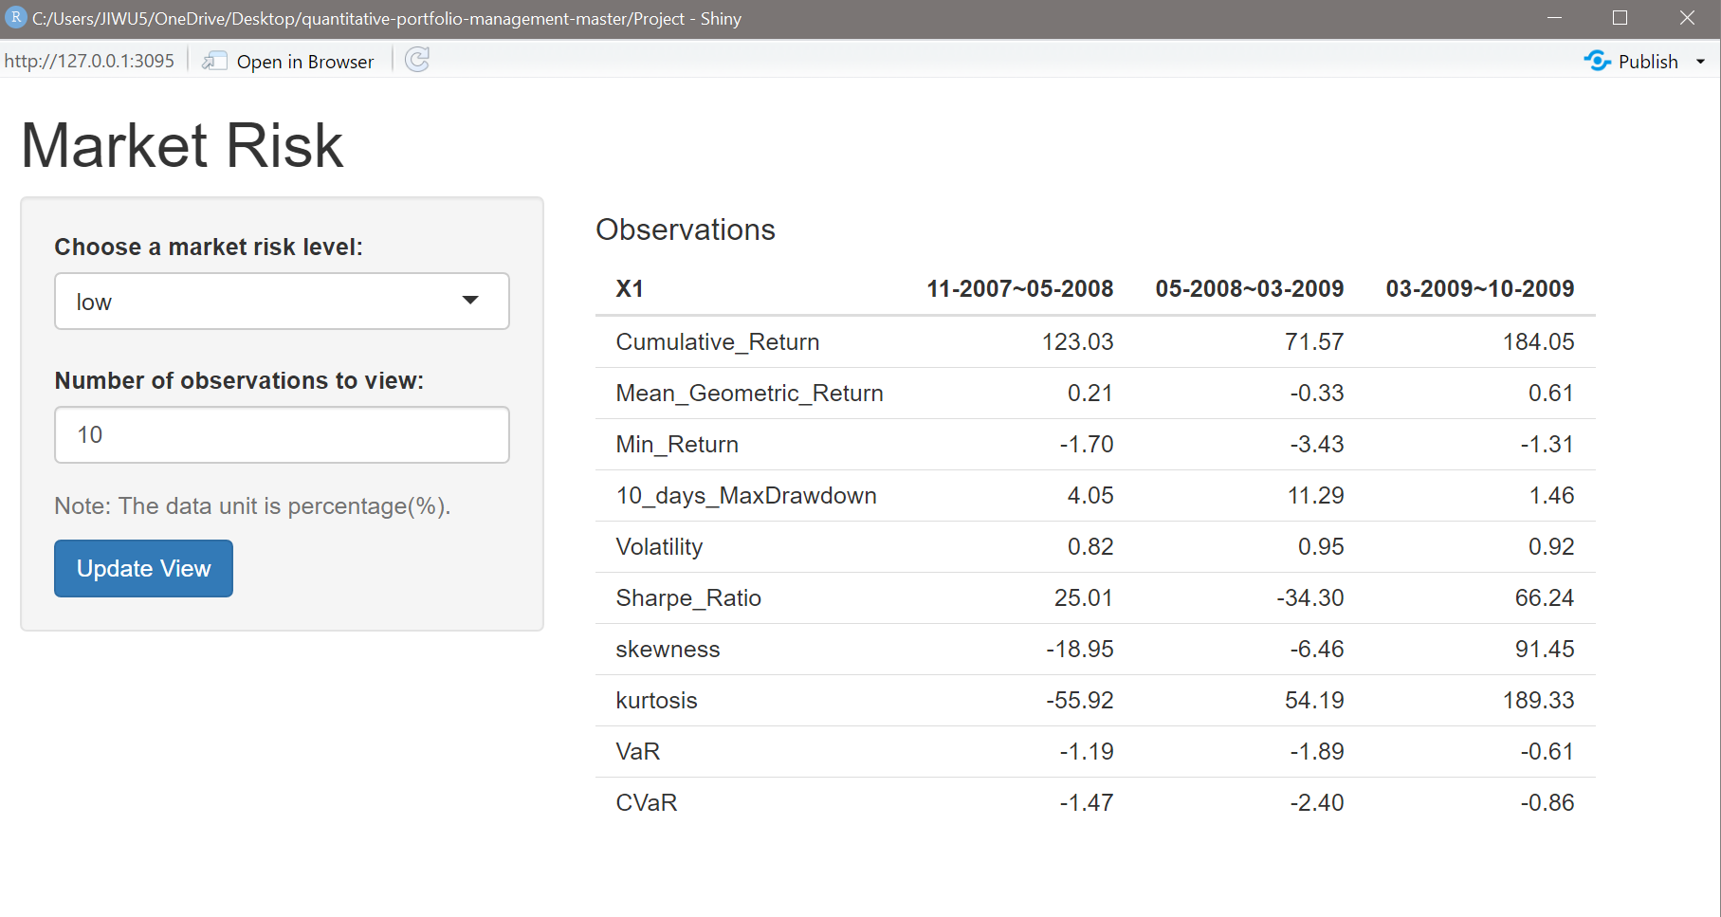

## Securities Performance

When the target beta is 1.5, the performance of securities is shown as below.

|  |  |  |  |  |  |  |  |
| --- | --- | --- | --- | --- | --- | --- | --- |
|  | fxe | ewj | gld | qqq | spy | shv | dba |
| Cumulative_Return | 0.9658 | 1.2762 | 0.9022 | 1.4392 | 1.2171 | 0.9922 | 1.0225 |
| Mean_Geometric_Return | -0.0006 | 0.0040 | -0.0017 | 0.0060 | 0.0032 | -0.0001 | 0.0004 |
| Min_Return | -0.0143 | -0.0219 | -0.0401 | -0.0123 | -0.0123 | -0.0020 | -0.0527 |
| 10_days_MaxDrawdown | 0.0370 | 0.0391 | 0.0909 | 0.0210 | 0.0218 | 0.0038 | 0.0993 |
| Volatility | 0.0065 | 0.0118 | 0.0163 | 0.0128 | 0.0100 | 0.0005 | 0.0176 |
| Sharpe_Ratio | -0.0874 | 0.3425 | -0.0966 | 0.4712 | 0.3249 | -0.2975 | 0.0281 |
| skewness | 0.1376 | 0.3118 | -0.3499 | 1.0528 | 1.5960 | -2.1319 | -0.2874 |
| kurtosis | -0.3511 | 0.0145 | -0.5748 | 0.7699 | 3.2709 | 4.4456 | 0.7108 |
| VaR | -0.0110 | -0.0142 | -0.0299 | -0.0106 | -0.0074 | -0.0012 | -0.0294 |
| CVaR | -0.0131 | -0.0179 | -0.0353 | -0.0160 | -0.0189 | -0.0015 | -0.0403 |

|  |  |  |  |  |  |  |
| --- | --- | --- | --- | --- | --- | --- |
|  | uso | xbi | ilf | gaf | epp | fez |
| Cumulative_Return | 1.0941 | 1.4109 | 1.4060 | 1.2049 | 1.2394 | 1.1906 |
| Mean_Geometric_Return | 0.0015 | 0.0057 | 0.0056 | 0.0031 | 0.0035 | 0.0029 |
| Min_Return | -0.0366 | -0.0209 | -0.0348 | -0.0275 | -0.0242 | -0.0156 |
| 10_days_MaxDrawdown | 0.0991 | 0.0227 | 0.0625 | 0.0395 | 0.0460 | 0.0316 |
| Volatility | 0.0203 | 0.0141 | 0.0173 | 0.0121 | 0.0132 | 0.0099 |
| Sharpe_Ratio | 0.0815 | 0.4063 | 0.3318 | 0.2573 | 0.2711 | 0.2913 |
| skewness | -0.0065 | 0.7937 | 0.1509 | 0.3496 | 0.4153 | 0.8932 |
| kurtosis | -0.6656 | 0.3492 | 0.3890 | 0.6211 | 0.4983 | 1.2210 |
| VaR | -0.0318 | -0.0138 | -0.0215 | -0.0152 | -0.0163 | -0.0104 |
| CVaR | -0.0378 | -0.0179 | -0.0287 | -0.0195 | -0.0206 | -0.0133 |

Table.5 Securities performance

# Conclusion

From the results, the best portfolio performance indicates the best parameters: Target beta is 1.5, long period investment, and the time span is 03/2009 ~ 10/2009. This is mainly because the market recovered fast after the crisis. The performance would benefit if the portfolio had a high correlation with the market movement. Instead, when the market crashes, the lower is the beta, the better the portfolio performance can be. In general, compared with market risk, timing the market(time span) is much more important, as per the results of long/short portfolio performance with different target Betas. Investment after crisis can realize appreciable profit with relatively low risk, for example the annualized Sharpe Ratio is above 9.0. This is mainly caused by government stimulus plans and central bank policies after the crisis.